***JAYPEE INSTITUTE OF INFORMATION***

***TECHNOLOGY, NOIDA , SECTOR-62***



***PHYSICS-2***

***PROJECT BASED LEARNING***

***Hard disk Drive***

***SUBMITTED TO:***

***Dr. Ravi Gupta***

***BY :***

***TEAM MEMBERS (B10 BATCH):***

* ***HIMANSHU DIXIT (21103262)***
* ***ROHAN SIWACH (21103261)***
* ***ARYAMAN VISHNOI (21103260)***
* ***PARUSH SHARMA (21103259)***

***(BTECH – CSE 2nd  SEMESTER)***

***content***

* ***Acknowledgement***
* ***Introduction***
* ***Technology used in HDDs***
* ***Capacity of hard drives***
* ***Price evolution***
* ***Performance characterstics***
* ***Lateral characterstics***
* ***Market segements***
* ***Manufacture and sales***
* ***Competition from SSDs***
* ***Conclusion***
* ***Refernces***

***acknowledgement***

*We extend our sincere thanks to* ***Jaypee Institute of Information and Technology*** *which provided us the opportunity to make the project using Physics concept which helped us implement and improve skills we have learned till now. We also take this opportunity to express a deep sense of gratitude to* ***Dr. Ravi Gupta Sir*** *for his cordial support, valuable suggestions and guidance. We would like to thank our friends and family for the support and encouragement they have given us during the course of work.*

* *HIMANSHU DIXIT (21103262)*
* *ROHAN SIWACH (21103261)*
* *ARYAMAN VISHNOI (21103260)*
* *PARUSH SHARMA (21103259)*

***INTRODUCTION***

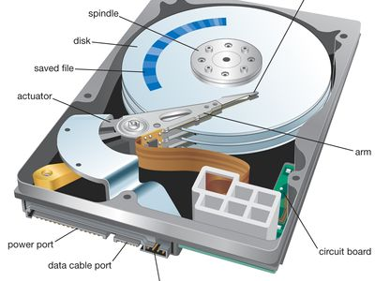 

**About :-**

*A hard disk drive (HDD), hard disk, hard drive, or fixed disk is an electro-mechanical data storage device that stores and retrieves digital data using magnetic storage and one or more rigid rapidly rotating platters coated with magnetic material. The platters are paired with magnetic heads, usually arranged on a moving actuator arm, which read and write data to the platter surfaces. Data is accessed in a random-access manner, meaning that individual blocks of data can be stored and retrieved in any order. HDDs are a type of non-volatile storage, retaining stored data even when powered off. Modern HDDs are typically in the form of a small rectangular box.*

*The primary characteristics of an HDD are its capacity and performance. Capacity is specified in unit prefixes corresponding to powers of 1000: a 1-terabyte(TB) drive has a capacity of 1,000 gigabytes (GB; where 1 gigabyte = 1 billion (109) bytes). Typically, some of an HDD's capacity is unavailable to the user because it is used by the file system and the computer operating system, and possibly inbuilt redundancy for error correction and recovery. Also there is confusion regarding storage capacity, since capacities are stated in decimal gigabytes (powers of 1000) by HDD manufacturers, whereas the most commonly used operating systems report capacities in powers of 1024, which results in a smaller number than advertised. Performance is specified by the time required to move the heads to a track or cylinder (average access time) adding the time it takes for the desired sector to move under the head (average latency , which is a function of the physical rotational speed in revolutions per minute), and finally the speed at which the data is transmitted (data rate).*

***TECHNOLOGY USED IN HDDS***

* ***Magnetic Recording :-***

*A modern HDD records data by magnetizing a thin film of ferromagnetic material on both sides of a disk. Sequential changes in the direction of magnetization represent binary data bits. The data is read from the disk by detecting the transitions in magnetization. User data is encoded using an encoding scheme, such as run-length limited encoding, which determines how the data is represented by the magnetic transitions. The platters in contemporary HDDs are spun at speeds varying from 4,200 RPM in energy-efficient portable devices, to 15,000 RPM for high-performance servers. The first HDDs spun at 1,200 RPM and, for many years, 3,600 RPM was the norm. As of November 2019, the platters in most consumer-grade HDDs spin at 5,400 or 7,200 RPM. Information is written to and read from a platter as it rotates past devices called read-and-write heads that are positioned to operate very close to the magnetic surface, with their flying height often in the range of tens of nanometers. The read-and-write head is used to detect and modify the magnetization of the material passing immediately under it.*

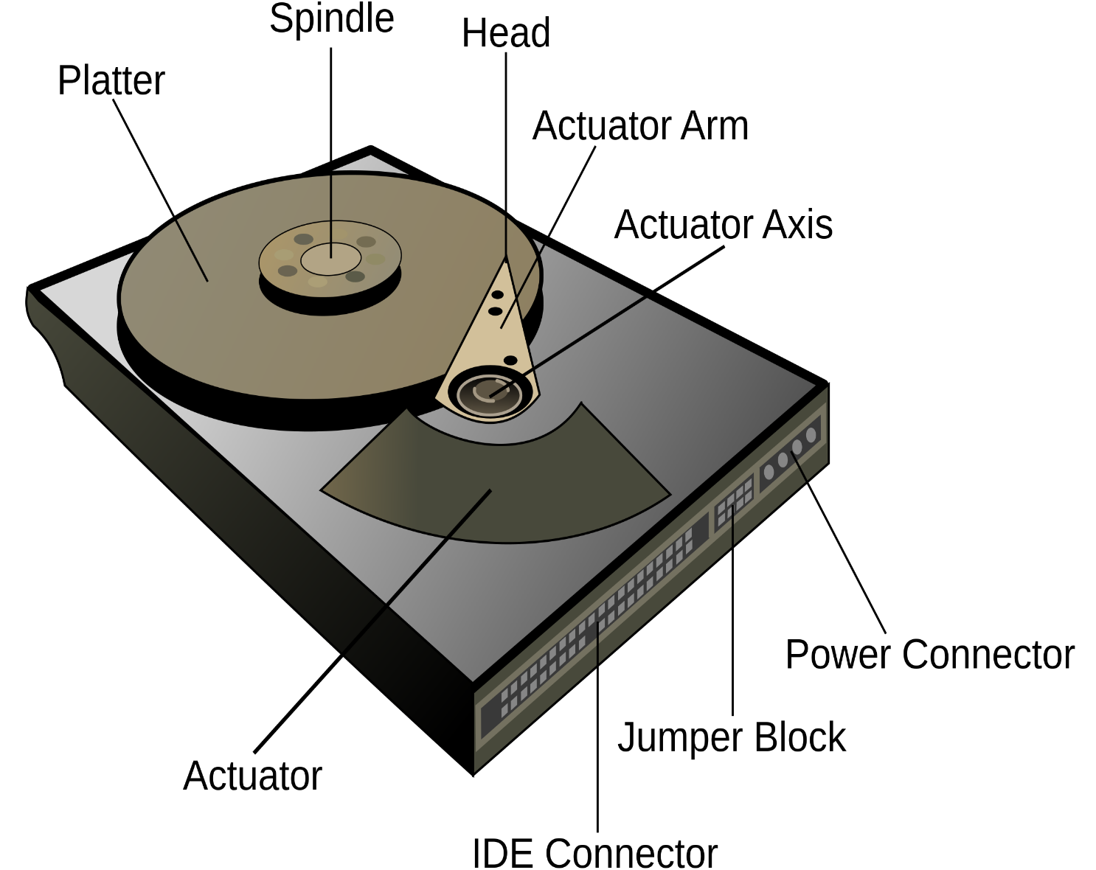

*In modern drives, there is one head for each magnetic platter surface on the spindle, mounted on a common arm. An actuator arm (or access arm) moves the heads on an arc (roughly radially) across the platters as they spin, allowing each head to access almost the entire surface of the platter as it spins. The arm is moved using a voice coil actuator or in some older designs a stepper motor. Early hard disk drives wrote data at some constant bits per second, resulting in all tracks having the same amount of data per track but modern drives (since the 1990s) use zone bit recording – increasing the write speed from inner to outer zone and thereby storing more data per track in the outer zones.*

*In modern drives, the small size of the magnetic regions creates the danger that their magnetic state might be lost because of thermal effects⁠ ⁠— thermally induced magnetic instability which is commonly known as the "superparamagnetic limit". To counter this, the platters are coated with two parallel magnetic layers, separated by a three-atom layer of the non-magnetic element ruthenium, and the two layers are magnetized in opposite orientation, thus reinforcing each other. Another technology used to overcome thermal effects to allow greater recording densities is perpendicular recording, first shipped in 2005, and as of 2007 used in certain HDDs.*

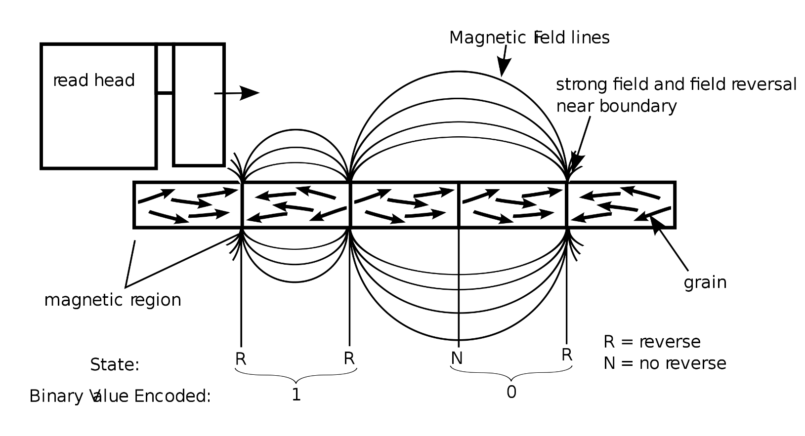

* ***Components :-***

*A typical HDD has two electric motors: a spindle motor that spins the disks and an actuator (motor) that positions the read/write head assembly across the spinning disks. The disk motor has an external rotor attached to the disks; the stator windings are fixed in place. Opposite the actuator at the end of the head support arm is the read-write head; thin printed-circuit cables connect the read-write heads to amplifier electronics mounted at the pivot of the actuator. The head support arm is very light, but also stiff; in modern drives, acceleration at the head reaches 550 g.*

*The actuator is a permanent magnet and moving coil motor that swings the heads to the desired position. A metal plate supports a squat neodymium-iron-boron (NIB) high-flux magnet. Beneath this plate is the moving coil, often referred to as the voice coil by analogy to the coil in loudspeakers, which is attached to the actuator hub, and beneath that is a second NIB magnet, mounted on the bottom plate of the motor (some drives have only one magnet).*

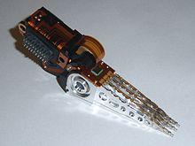*The HDD's electronics control the movement of the actuator and the rotation of the disk and perform reads and writes on demand from the disk controller. Feedback of the drive electronics is accomplished by means of special segments of the disk dedicated to servo feedback. These are either complete concentric circles (in the case of dedicated servo technology) or segments interspersed with real data (in the case of embedded servo technology). The servo feedback optimizes the signal-to-noise ratio of the GMR sensors by adjusting the voice coil of the actuated arm. The spinning of the disk also uses a servo motor. Modern disk firmware is capable of scheduling reads and writes efficiently on the platter surfaces and remapping sectors of the media that have failed.*

The image on the left is of an Head Stack with an actuator coil on the left and read/write heads on the right.

* ***Error rates and Handling :-***

*Modern drives make extensive use of error correction codes (ECCs), particularly Reed–Solomon error correction. These techniques store extra bits, determined by mathematical formulas, for each block of data; the extra bits allow many errors to be corrected invisibly. The extra bits themselves take up space on the HDD, but allow higher recording densities to be employed without causing uncorrectable errors, resulting in much larger storage capacity. For example, a typical 1*[*TB*](https://en.wikipedia.org/wiki/Terabyte)*hard disk with 512-byte sectors provides additional capacity of about 93*[*GB*](https://en.wikipedia.org/wiki/Gibibyte)*for the ECC data.*

*In the newest drives, as of 2009, low-density parity-check codes (LDPC) were supplanting Reed–Solomon; LDPC codes enable performance close to the Shannon Limit and thus provide the highest storage density available.*

*Typical hard disk drives attempt to "remap" the data in a physical sector that is failing to a spare physical sector provided by the drive's "spare sector pool" (also called "reserve pool"), while relying on the ECC to recover stored data while the number of errors in a bad sector is still low enough. The S.M.A.R.T (Self-Monitoring, Analysis and Reporting Technology) feature counts the total number of errors in the entire HDD fixed by ECC (although not on all hard drives as the related S.M.A.R.T attributes "Hardware ECC Recovered" and "Soft ECC Correction" are not consistently supported), and the total number of performed sector remappings, as the occurrence of many such errors may predict an HDD failure.*

*The "No-ID Format", developed by IBM in the mid-1990s, contains information about which sectors are bad and where remapped sectors have been located.*

*Only a tiny fraction of the detected errors end up as not correctable. Examples of specified uncorrected bit read error rates include:*

* + *2013 specifications for enterprise SAS disk drives state the error rate to be one uncorrected bit read error in every 1016 bits read,*
  + *2018 specifications for consumer SATA hard drives state the error rate to be one uncorrected bit read error in every 1014 bits.*

*Within a given manufacturers model the uncorrected bit error rate is typically the same regardless of capacity of the drive.*

*The worst type of errors are*[*silent data corruptions*](https://en.wikipedia.org/wiki/Silent_data_corruption)*which are errors undetected by the disk firmware or the host operating system; some of these errors may be caused by hard disk drive malfunctions while others originate elsewhere in the connection between the drive and the host.*

***CAPACITY OF HARD DRIVES***

*The highest-capacity HDDs shipping commercially in 2022 are 20 TB. The capacity of a hard disk drive, as reported by an operating system to the end user, is smaller than the amount stated by the manufacturer for several reasons: the operating system using some space, use of some space for data redundancy, and space use for file system structures. Also the difference in capacity reported in SI decimal prefixed units vs. binary prefixes can lead to a false impression of missing capacity.*

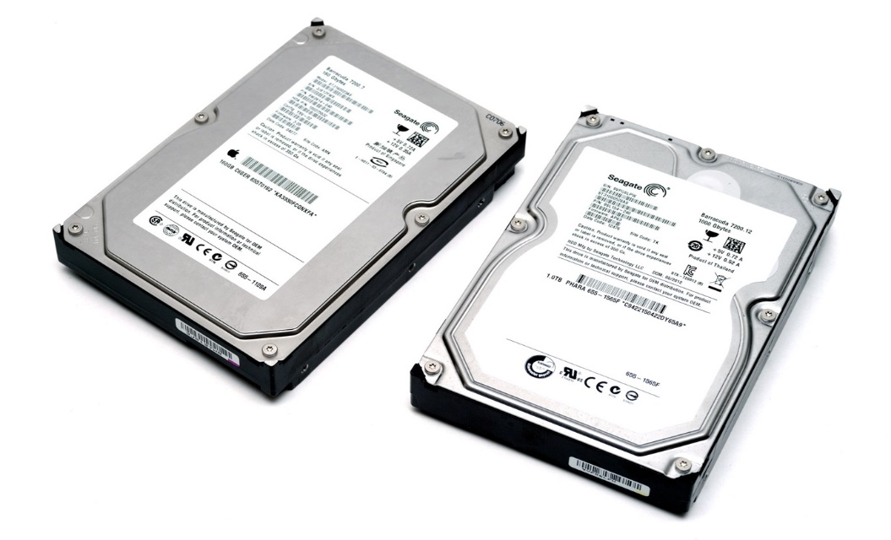

Two Seagate Barracuda drives, from 2003 and 2009 - respectively 160GB and 1TB.

***PRICE EVOLUTION***

*HDD price per byte decreased at the rate of 40% per year during 1988–1996, 51% per year during 1996–2003 and 34% per year during 2003–2010. The price decrease slowed down to 13% per year during 2011–2014, as areal density increase slowed and the 2011 Thailand floods damaged manufacturing facilities and have held at 11% per year during 2010–2017*

***PERFORMANCE CHARACTERSTICS***

*The factors that limit the time to access the data on an HDD are mostly related to the mechanical nature of the rotating disks and moving heads, including:*

* *Seek time is a measure of how long it takes the head assembly to travel to the track of the disk that contains data.*
* *Rotational latency is incurred because the desired disk sector may not be directly under the head when data transfer is requested. Average rotational latency is shown in the table, based on the statistical relation that the average latency is one-half the rotational period.*
* *The bit rate or data transfer rate (once the head is in the right position) creates delay which is a function of the number of blocks transferred; typically relatively small, but can be quite long with the transfer of large contiguous files.*

*Delay may also occur if the drive disks are stopped to save energy. Defragmentation is a procedure used to minimize delay in retrieving data by moving related items to physically proximate areas on the disk. Some computer operating systems perform defragmentation automatically. Although automatic defragmentation is intended to reduce access delays, performance will be temporarily reduced while the procedure is in progress.*

*Time to access data can be improved by increasing rotational speed (thus reducing latency) or by reducing the time spent seeking. Increasing areal density increases throughput by increasing data rate and by increasing the amount of data under a set of heads, thereby potentially reducing seek activity for a given amount of data. The time to access data has not kept up with throughput increases, which themselves have not kept up with growth in bit density and storage capacity.*

***LATERAL CHARACTERSTICS***

|  |  |
| --- | --- |
| **Rotational speed [rpm]** | **Average rotational latency [ms]** |
| 15,000 | 2 |
| 10,000 | 3 |
| 7,200 | 4.16 |
| 5,400 | 5.55 |
| 4,800 | 6.25 |

***Data Transfer Rate :-***

*As of 2010, a typical 7,200-rpm desktop HDD has a sustained "disk-to-buffer" data transfer rate up to 1,030 Mbit/s. This rate depends on the track location; the rate is higher for data on the outer tracks (where there are more data sectors per rotation) and lower toward the inner tracks (where there are fewer data sectors per rotation); and is generally somewhat higher for 10,000-rpm drives. A current widely used standard for the "buffer-to-computer" interface is 3.0 Gbit/s SATA, which can send about 300 megabyte/s (10-bit encoding) from the buffer to the computer, and thus is still comfortably ahead of today's disk-to-buffer transfer rates. Data transfer rate (read/write) can be measured by writing a large file to disk using special file generator tools, then reading back the file. Transfer rate can be influenced by file system fragmentation and the layout of the files.*

***Integrity and Failure :-***

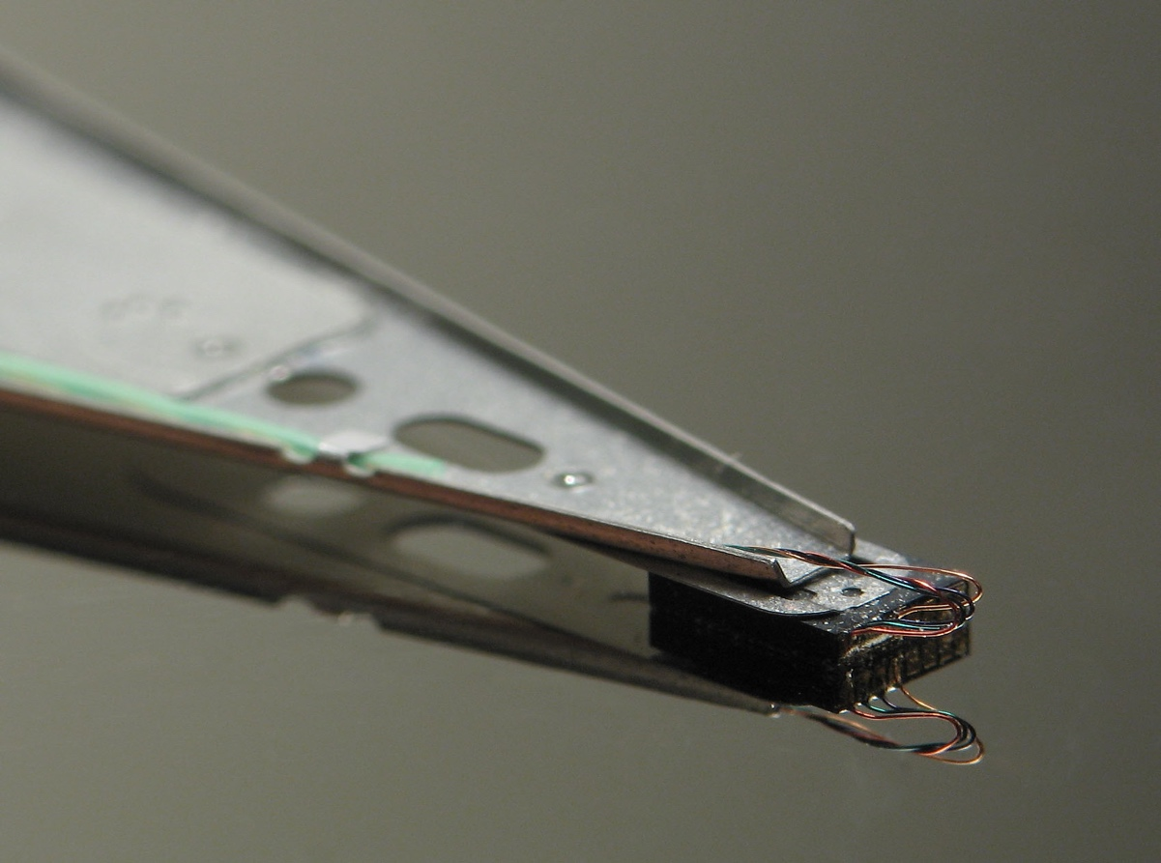*Due to the extremely close spacing between the heads and the disk surface, HDDs are vulnerable to being damaged by a head crash – a failure of the diskin which the head scrapes across the platter surface, often grinding away the thin magnetic film and causing data loss. Head crashes can be caused by electronic failure, a sudden power failure, physical shock, contamination of the drive's internal enclosure, wear and tear, corrosion, or poorly manufactured platters and heads.*

Close-up of an HDD head resting on a disk platter; its mirror reflection is visible on the platter surface. Unless the head is on a landing zone, the heads touching the platters while in operation can be catastrophic.

The HDD's spindle system relies on air density inside the disk enclosure to support the heads at their proper flying height while the disk rotates. HDDs require a certain range of air densities to operate properly. The connection to the external environment and density occurs through a small hole in the enclosure (about 0.5 mm in breadth), usually with a filter on the inside (the breather filter). If the air density is too low, then there is not enough lift for the flying head, so the head gets too close to the disk, and there is a risk of head crashes and data loss. Specially manufactured sealed and pressurized disks are needed for reliable high-altitude operation, above about 3,000 m (9,800 ft). Modern disks include temperature sensors and adjust their operation to the operating environment. Breather holes can be seen on all disk drives – they usually have a sticker next to them, warning the user not to cover the holes. The air inside the operating drive is constantly moving too, being swept in motion by friction with the spinning platters. This air passes through an internal recirculation (or "recirc") filter to remove any leftover contaminants from manufacture, any particles or chemicals that may have somehow entered the enclosure, and any particles or outgassing generated internally in normal operation. Very high humidity present for extended periods of time can corrode the heads and platters. An exception to this are hermetically sealed, helium filled HDDs that largely eliminate environmental issues that can arise due to humidity or atmospheric pressure changes. Such HDDs were introduced by HGST in their first successful high volume implementation in 2013.

***MARKET SEGMENTS***

* **Consumer Segment :**

1. **Desktop HDDs –**

Desktop HDDs typically have two to five internal platters, rotate at 5,400 to 10,000 rpm, and have a media transfer rate of 0.5 Gbit/s or higher (1 GB = 109 bytes; 1 Gbit/s = 109 bit/s). Earlier (1980-1990s) drives tend to be slower in rotation speed. As of May 2019, the highest-capacity desktop HDDs stored 16 TB, with plans to release 18 TB drives later in 2019. 18 TB HDDs were released in 2020.

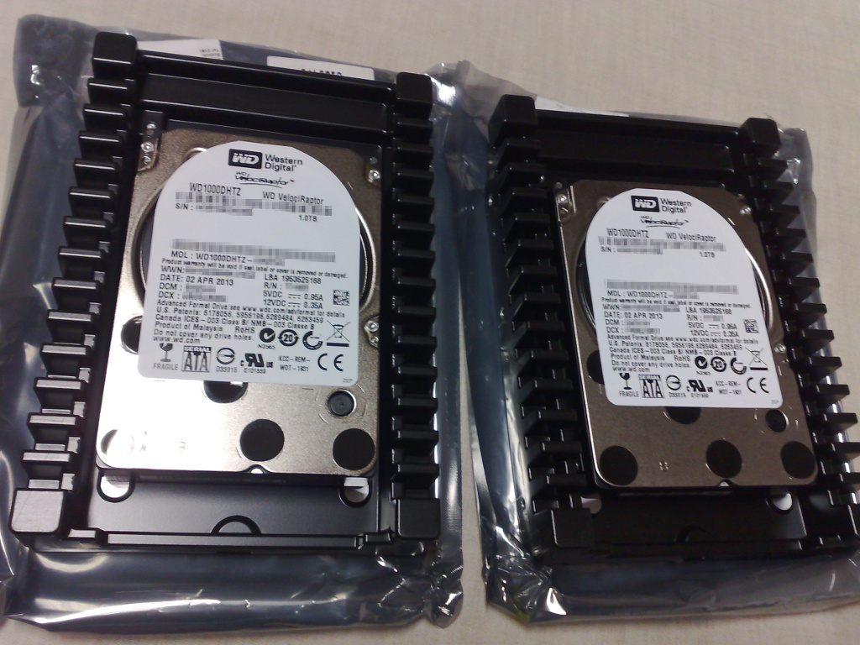

Two high-end consumer SATA 2.5-inch 10,000 rpm HDDs, factory-mounted in 3.5-inch adapter frames

1. **Mobile(laptop) HDDs –**

*Smaller than their desktop and enterprise counterparts, they tend to be slower and have lower capacity, because typically has one internal platter and were 2.5" or 1.8" physical size instead of more common for desktops 3.5" form-factor. Mobile HDDs spin at 4,200 rpm, 5,200 rpm, 5,400 rpm, or 7,200 rpm, with 5,400 rpm being the most common. 7,200 rpm drives tend to be more expensive and have smaller capacities, while 4,200 rpm models usually have very high storage capacities. Because of smaller platter(s), mobile HDDs generally have lower capacity than their desktop counterparts.*

1. ***Consumer Electronic HDDs* –**

*They include drives embedded into digital video recorders and*

*automotive vehicles. The former are configured to provide a guaranteed streaming capacity, even in the face of read and write errors, while the latter are built to resist larger amounts of shock. They usually spin at a speed of 5400 RPM.*

1. ***External and portable HDDs* –**

*Current external hard disk drives typically connect via USB-C; earlier models use a regular USB (sometimes with using of a pair of ports for better bandwidth) or (rarely), e.g., eSATA connection. Variants using USB 2.0 interface generally have slower data transfer rates when compared to internally mounted hard drives connected through SATA. Plug and play drive functionality offers system compatibility and features large storage options and portable design. As of March 2015, available capacities for external hard disk drives ranged from 500 GB to 10 TB. External hard disk drives are usually available as assembled integrated products but may be also assembled by combining an external enclosure (with USB or other interface) with a separately purchased drive. They are available in 2.5-inch and 3.5-inch sizes; 2.5-inch variants are typically called portable external drives, while 3.5-inch variants are referred to as desktop external drives. "Portable" drives are packaged in smaller and lighter enclosures than the "desktop" drives; additionally, "portable" drives use power provided by the USB connection, while "desktop" drives require external power bricks.*

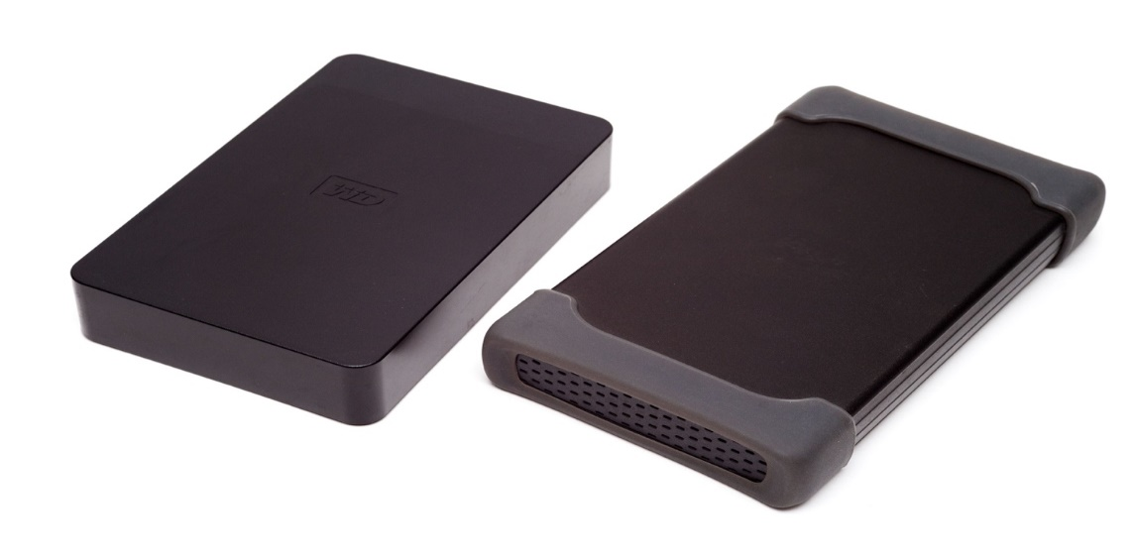

Two 2.5" external USB hard drives

* **Enterprise and business segment :**

1. **Server and Workstation HDDs –**

*Typically used with multiple-user computers running enterprise software. Examples are: transaction processing databases, internet infrastructure (email, webserver, e-commerce), scientific computing software, and nearline storage management software. Enterprise drives commonly operate continuously in demanding environments while delivering the highest possible performance without sacrificing reliability. Maximum capacity is not the primary goal, and as a result the drives are often offered in capacities that are relatively low in relation to their cost.*

*The fastest enterprise HDDs spin at 10,000 or 15,000 rpm, and can achieve sequential media transfer speeds above 1.6 Gbit/sand a sustained transfer rate up to 1 Gbit/s. Drives running at 10,000 or 15,000 rpm use smaller platters to mitigate increased power requirements (as they have less air drag) and therefore generally have lower capacity than the highest capacity desktop drives. Enterprise HDDs are commonly connected through Serial Attached SCSI (SAS) or Fibre Channel (FC). Some support multiple ports, so they can be connected to a redundant host bus adapter.*

*Enterprise HDDs can have sector sizes larger than 512 bytes (often 520, 524, 528 or 536 bytes). The additional per-sector space can be used by hardware RAID controllers or applications for storing Data Integrity Field (DIF) or Data Integrity Extensions (DIX) data, resulting in higher reliability and prevention of silent data corruption.*

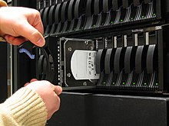

Hot-swappable HDD enclosure

1. ***Video Recording HDDs –***

*This line were similar to consumer video recording HDDs with stream stability requirements and similar to server HDDs with requirements to expandability support, but also they strongly oriented for growing of internal capacity. The main sacrifice for this segment is a writing and reading speed****.***

***Manufacture and sales***

*More than 200 companies have manufactured HDDs over time, but consolidations have concentrated production to just three manufacturers today: Western Digital, Seagate, and Toshiba. Production is mainly in the Pacific rim.*

*Worldwide revenue for disk storage declined eight percent per year, from a peak of $38 billion in 2012 to $22 billion (estimated) in 2019. Production of HDD storage grew 15% per year during 2011–2017, from 335 to 780 exabytes per year. HDD shipments declined seven percent per year during this time period, from 620 to 406 million units. HDD shipments were projected to drop by 18% during 2018–2019, from 375 million to 309 million units. In 2018, Seagate has 40% of unit shipments, Western Digital has 37% of unit shipments, while Toshiba has 23% of unit shipments. The average sales price for the two largest manufacturers was $60 per unit in 2015.*

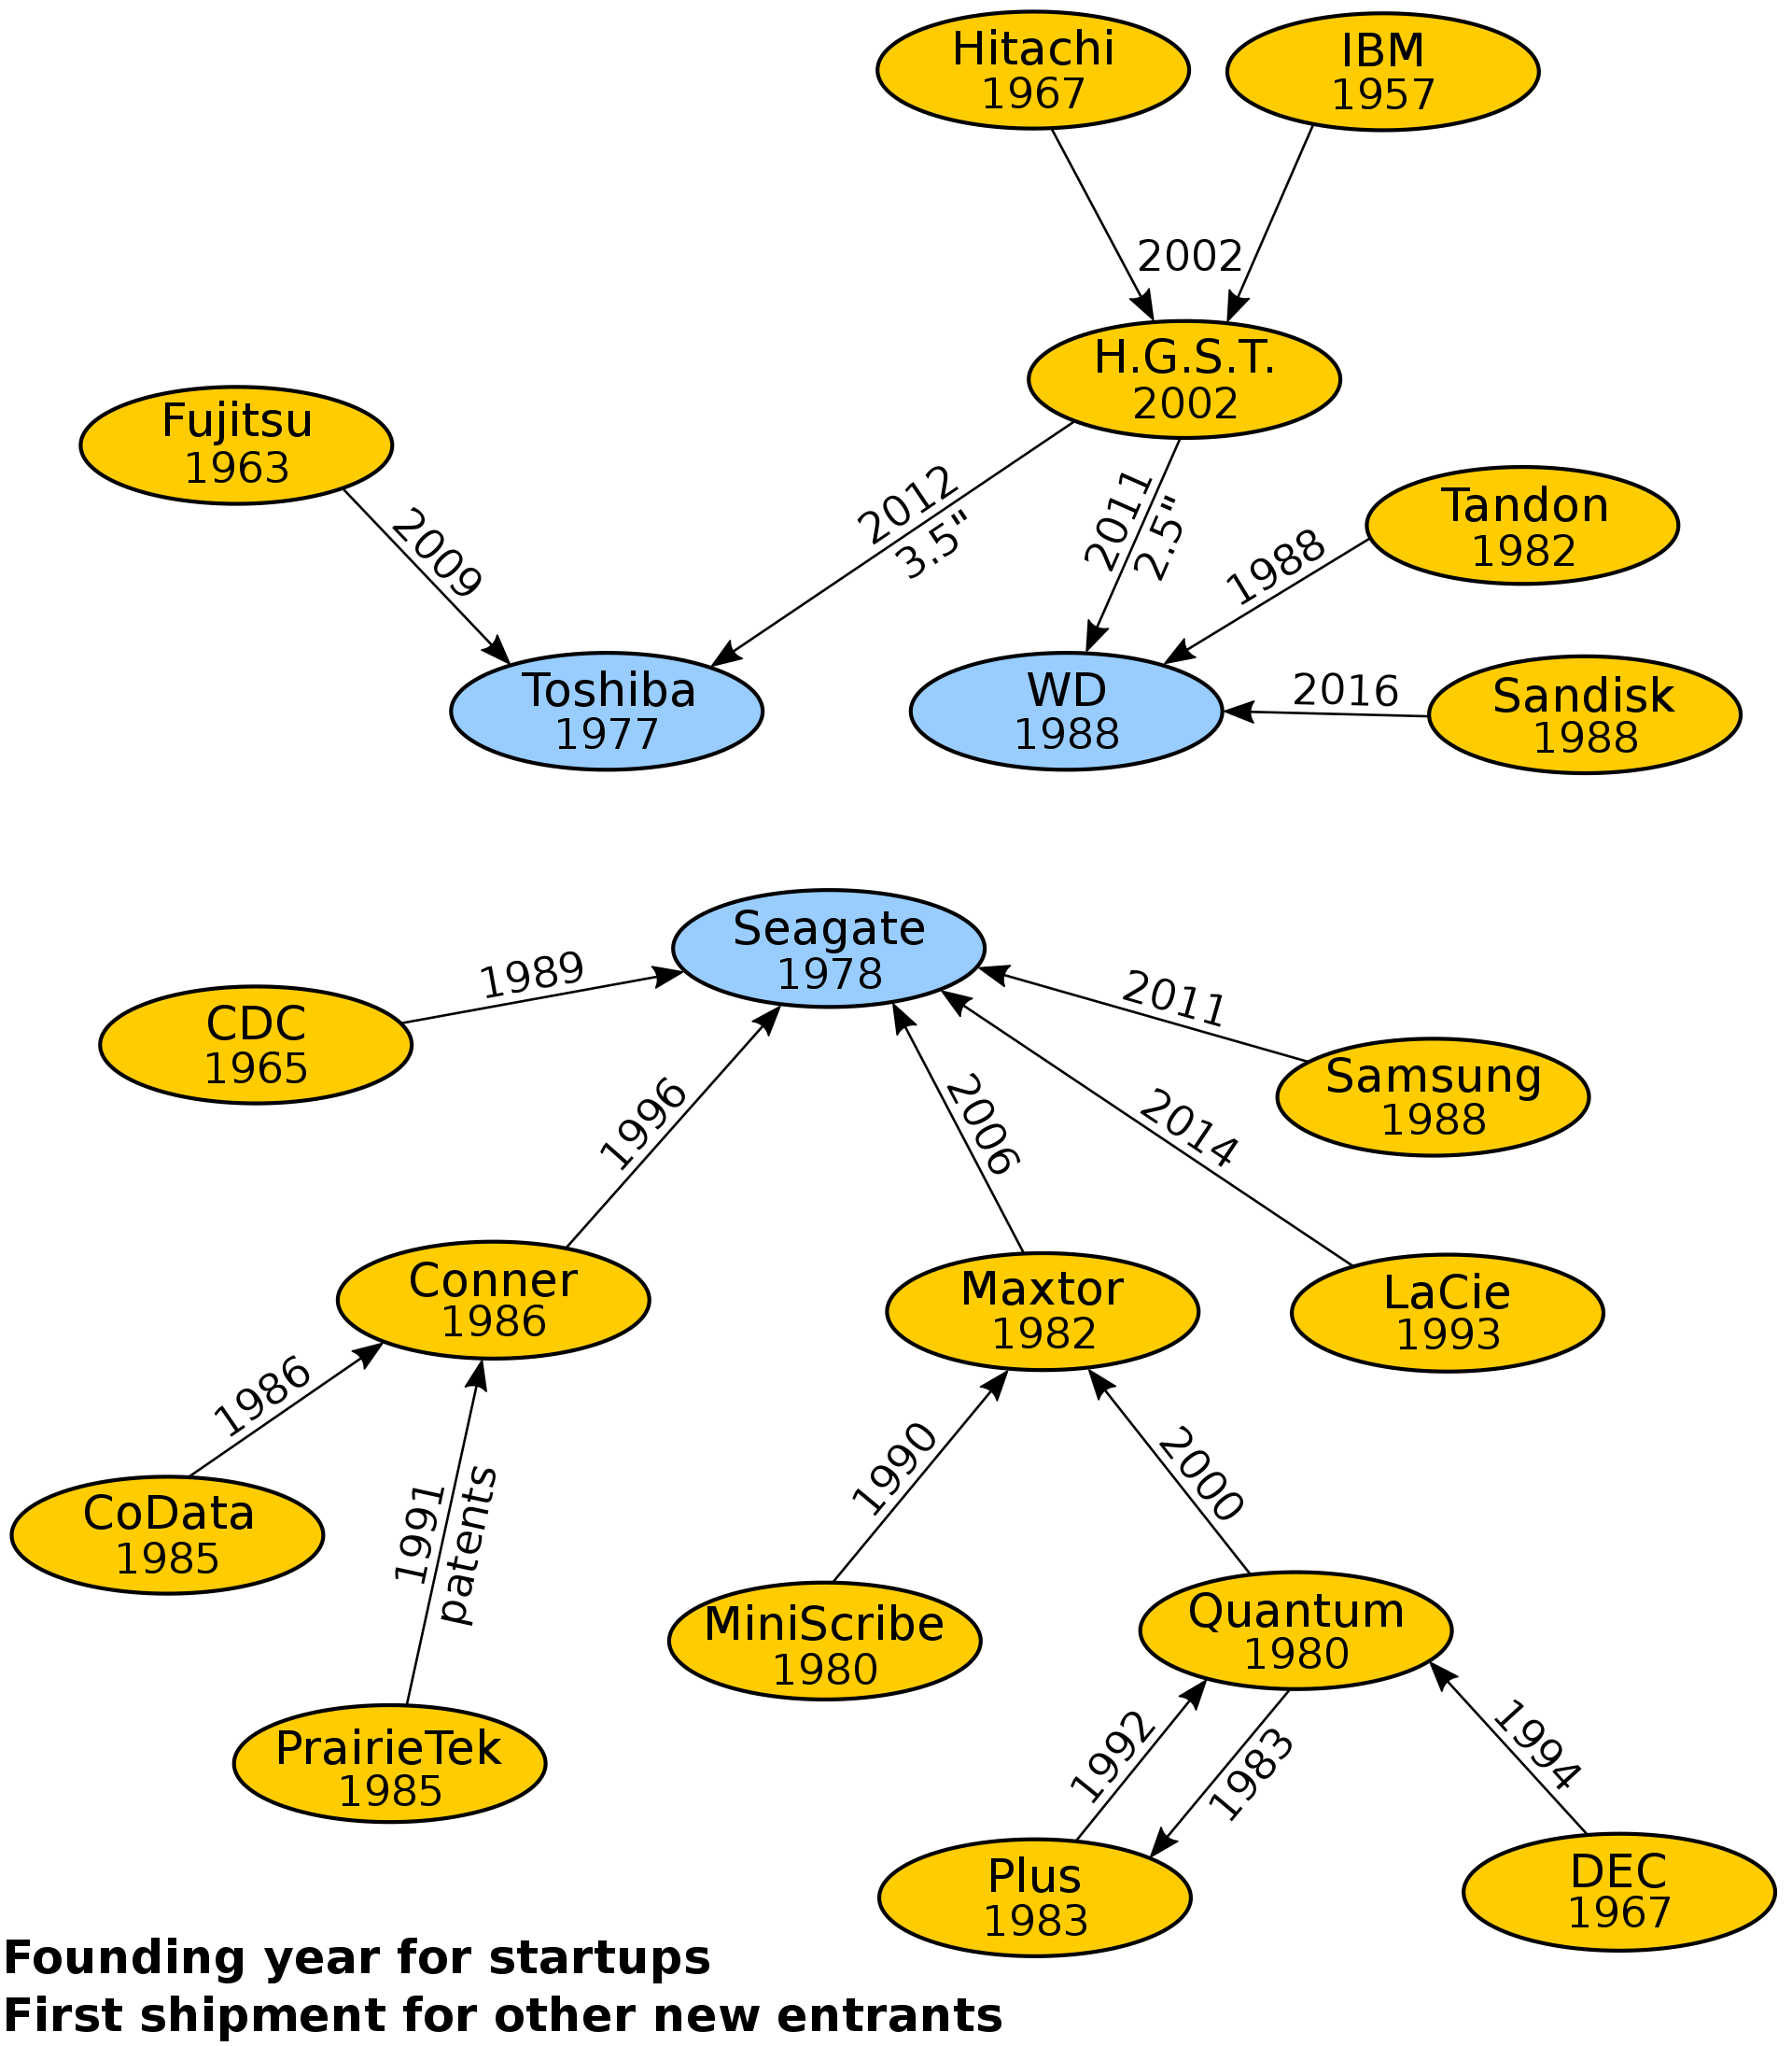

Diagram of HDD manufacturer consolidation.

***Competition from ssds***

*HDDs are being superseded by solid-state drives (SSDs) in markets where their higher speed (up to 4950 megabytes) (4.95 gigabytes) per second for M.2(NGFF) NVMe SSDs, or 2500 megabytes (2.5 gigabytes) per second for PCIe expansion card drives), ruggedness, and lower power are more important than price, since the bit cost of SSDs is four to nine times higher than HDDs. As of 2016, HDDs are reported to have a failure rate of 2–9% per year, while SSDs have fewer failures: 1–3% per year. However, SSDs have more un-correctable data errors than HDDs.*

*SSDs offer larger capacities (up to 100 TB) than the largest HDD and/or higher storage densities (100 TB and 30 TB SSDs are housed in 2.5 inch HDD cases but with the same height as a 3.5-inch HDD), although their cost remains prohibitive.*

*A laboratory demonstration of a 1.33-Tb 3D NAND chip with 96 layers (NAND commonly used in solid state drives (SSDs)) had 5.5 Tbit/in2 as of 2019, while the maximum areal density for HDDs is 1.5 Tbit/in2. The areal density of flash memory is doubling every two years, similar to Moore's law (40% per year) and faster than the 10–20% per year for HDDs. As of 2018, the maximum capacity was 16 terabytes for an HDD, and 100 terabytes for an SSD. HDDs were used in 70% of the desktop and notebook computers produced in 2016, and SSDs were used in 30%. The usage share of HDDs is declining and could drop below 50% in 2018–2019 according to one forecast, because SSDs are replacing smaller-capacity (less than one-terabyte) HDDs in desktop and notebook computers and MP3 players.*

*The market for silicon-based flash memory (NAND) chips, used in SSDs and other applications, is growing faster than for HDDs. Worldwide NAND revenue grew 16% per year from $22 billion to $57 billion during 2011–2017, while production grew 45% per year from 19 exabytes to 175 exabytes.*

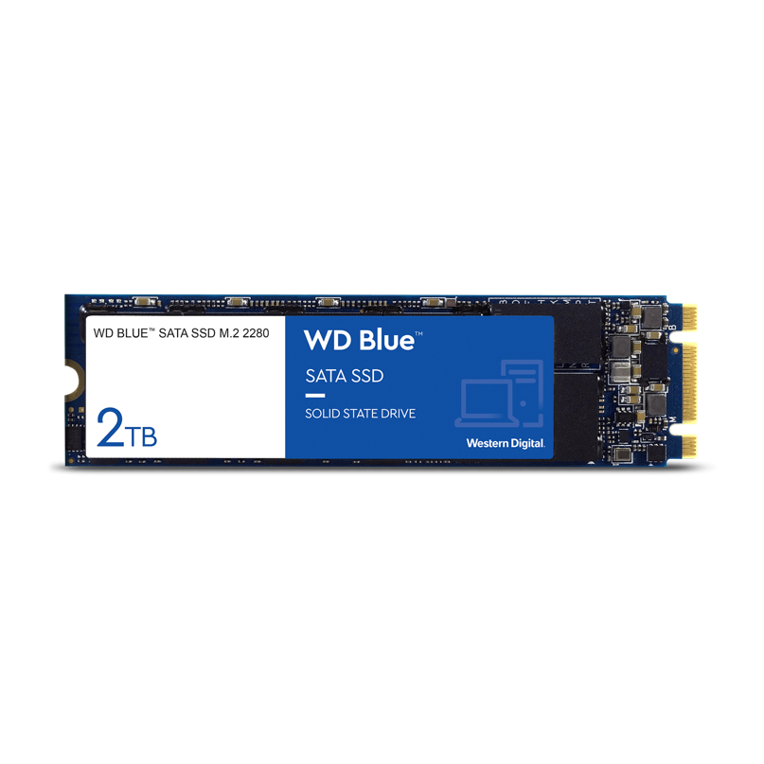

*Western Digital Blue SATA SSD M.2 2280*

***conclusion***

*A hard disk has revolutionized the digital age as we know it. Hard disks are the most widely used technology for storage of our information and data. Without hard disks the computer digital age we live in would not be the same.*

*It is the important hardware component cheaper than SSD other storage devices that stores all of your digital content. Your documents, pictures, music, videos, programs, application preferences, and operating system represent digital content stored on a hard drive. Hard drives can be external or internal.*

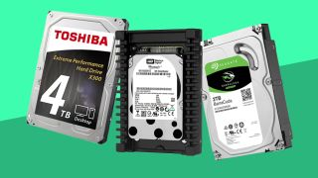

***references***

* [*https://en.wikipedia.org/wiki/Hard_disk_drive*](https://en.wikipedia.org/wiki/Hard_disk_drive)
* [*https://www.slideshare.net/achyutneupane/hard-disk-project*](https://www.slideshare.net/achyutneupane/hard-disk-project)
* [*www.google.com*](http://www.google.com)
* [*https://www.techopedia.com/definition/5288/hard-disk-drive*](https://www.techopedia.com/definition/5288/hard-disk-drive)

***Thanking***

***you***

Himanshu dixit

Rohan siwach

Parush sharma

Aryaman vishnoi